**AI ASSISTED CODING**

**LAB ASSIGNMENT – 6.5**

**SATHWIK V**

**2403A53002**

**24BTCAICYB01-2-1**

**#TASK-1**

Class Design Using AI Assistance:  
• Begin defining a Product class with attributes: name, price, quantity.  
• Use the AI suggestion feature to automatically complete the __init__() method.  
• Add a method calculate_value() to return price * quantity.

**PROMPT:**

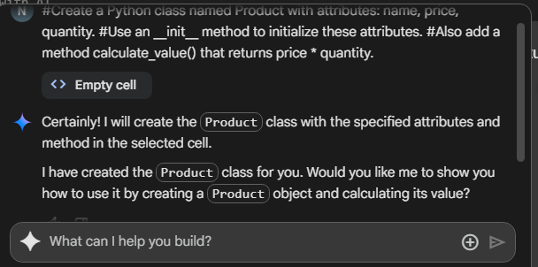

**OUTPUT:**

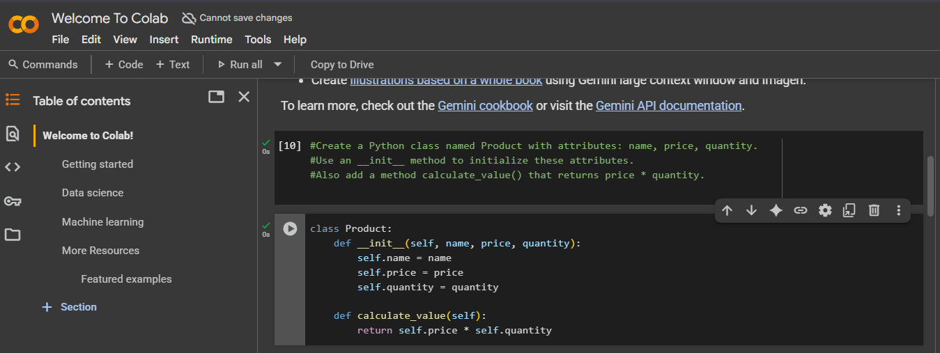

**#TASK-2**

Define a Warehouse class with a list of Product objects.  
• Use code completion to help implement:  
o A method to add a product.  
o A method to display the most valuable product.

**PROMPT:**

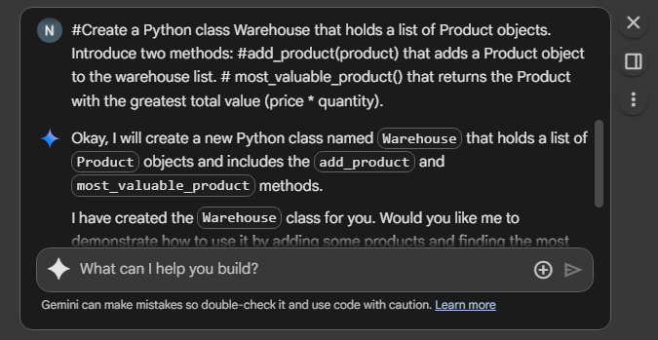

**OUTPUT:**

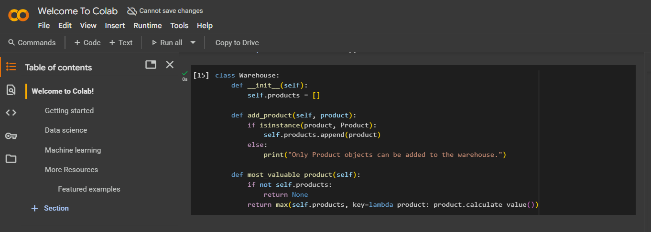

**SUMMARY:**

In this task, I had to create two classes in Python: Product and Warehouse. The Product class had name, price, and quantity, and a method to calculate total value. The Warehouse class had to keep a list of products, allow adding new products, and show the most valuable product.

I used Git Hub Copilot for this. When I started writing the code, Copilot gave me suggestions automatically. It was a useful and time-saving experience.